Year 5 – Spring Term 2 Newsletter
Dear Parents/Carers,
Welcome back to another half term. It’s a short one – just under 5 weeks, but it’s great to see the weather beginning to warm, and the early signs of spring starting to show themselves. The lighter evenings certainly help too.
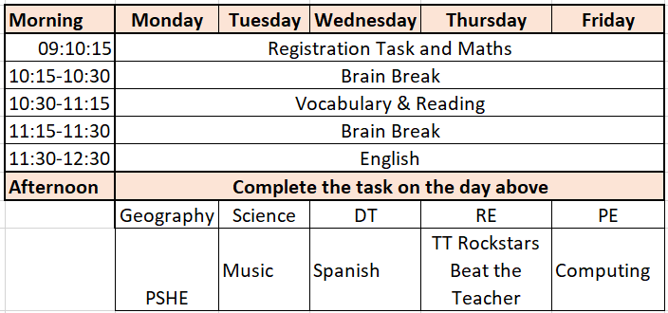
As I have told the class, I am really pleased with the motivation, commitment to learning and overall attitudes that they showed last term. Whether we return to school later in this term, or if it’s delayed a little longer, I know that the whole class will make the most of whatever setting they are in.
We have therefore moved to a fuller curriculum this term, regardless of whether we are teaching in person or remotely; two subjects will be expected to be completed each afternoon in addition to the morning’s live lessons.
Here is the updated timetable:
As per last term, Miss Worthington, our trainee teacher will be supporting the class again this half term before she returns to her other placement. An outline of this term’s topics is below:
The Amazon - We continue our geography theme; however, we are now looking more at human geography (the people, places and lifestyles those who live in or near to the Amazon).
Maths – we will continue with decimal fractions before moving on to percentages and geometry.
TT Rockstars is still available to use at home, and is a more interesting way to practise times table’s knowledge than just reciting them. NB The ‘Beat the Teacher’ challenge is at 2:30pm Thursdays.
Reading – Once we have finished reading Treasure Island, we will move on to some reading comprehension work, supporting children to understand how to answer these types of questions, and then on to Cloud Busting (below). Additional reading should still continue, 4 times per week.
Writing – This half term, the class will imagine their own chapter of Treasure Island based upon Jim Hawkins’ adventures there. They will also be creating a non-chronological report based upon a new unknown planet – linked to Science, and we will read the novel ‘Cloud Busting’ by Malorie Blackman, and use the poetic structures in the book as inspiration for our own work.
Science – This half term we are looking at ‘space’; focusing on the solar system, the Earth and Moon. Furthermore, we will review how have come to look past the ‘evidence’ we appear see with our eyes – that the Sun revolves around the Earth, and that the Earth is flat!
DT – We will also be designing and making our own ‘floating gardens’, as a project to help children understand how people who live in flood prone areas can lessen their impact.
As always, if you have any concerns or questions about any aspects of school – please get in touch.

Carl Bown
Year 5 Teacher

