Year 5 – Spring Term 1 Newsletter
Dear Parents/Carers,
As we navigate our way through a 3rd national lockdown, I want to make sure we do everything possible to minimise any disruptions to your child's learning.
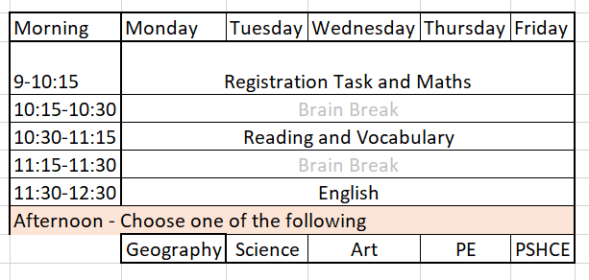
I will be teaching roughly 3 hours every morning via live video on Microsoft TEAMS - Maths and English (with breaks). Calendar invitations have already been sent to your child's Teams account. A timetable is below:

Pupil Contact and Uploading Work
As above, we are using MS Teams as a primary method of accessing lessons. This is also the platform for pupils to ask questions of me and to communicate with each other. Click here to access MS Teams.
Below is an outline of what we'll be studying remotely.
The Amazon - Our focus this half term moves away from history and into geography. The class will learn about rainforests: why they exist, how they benefit us, and the impact deforestation and climate change has upon them.
Maths – This half term is all about fractions, including decimal fractions. I’ve even taught the children a little dance to help them remember how to find fractions of an amount.
To calculate fractions, children need to know their times tables as they need to be able to divide by the denominator and times by the numerator. If your child isn’t secure in their times tables then they will need to complete this additional step – putting them at a disadvantage
TT Rockstars is still available to use at home, and is a more interesting way to practice times tables knowledge than just reciting them. We have a BEAT THE TEACHER Challenge every Thursday at 2:30 - which I know some of the class will be able to do.
Class Reading – We will be based upon the classic Treasure Island. It is accessible here for free.
Home Reading - The expectation is that children continue to complete 4 reads per week at home. Reading opens the door to new vocabulary, new story structures and worlds full of new information. Click here for ideas, activities and more information.
Writing – This half term we’re going to primarily focus on ‘writing to inform’. We shall create a report on the Amazon, and use this knowledge to help us write a short story based around the book: The Great Kapok Tree. We will find out about the life of the primatologist Jane Goodall in order to write her brief biography.
Science – Our other key focus is on ‘Living Things and Their Habitats’, where we will find out about the life cycles of various species of plants and animals along with understand how they reproduce.
Keeping in Contact
As always, if you have any concerns, or questions about this year – please get in touch. If you're unable to speak to me at the beginning or end of the day, message me via Class Dojo as I will always respond that way.
Best Wishes and Stay Safe,

Carl Bown
Year 5 Teacher

