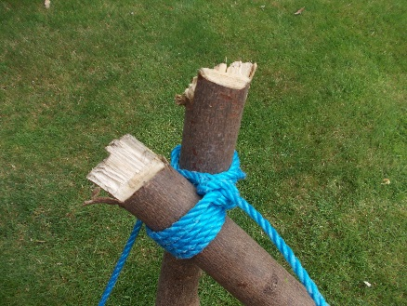
Shear Lashing
A shear lashing is used to attach poles to make either an A frame or a tripod.
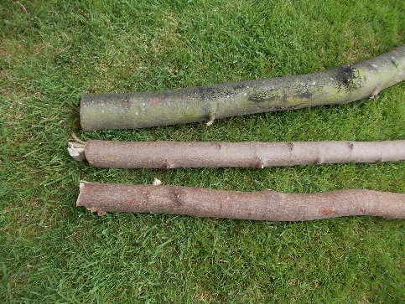
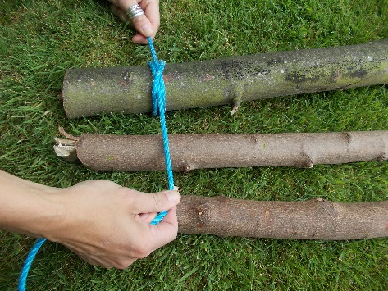
Tie you rope or string to a pole or stick.
Wrap the rope or string around all of the poles or sticks a few times.
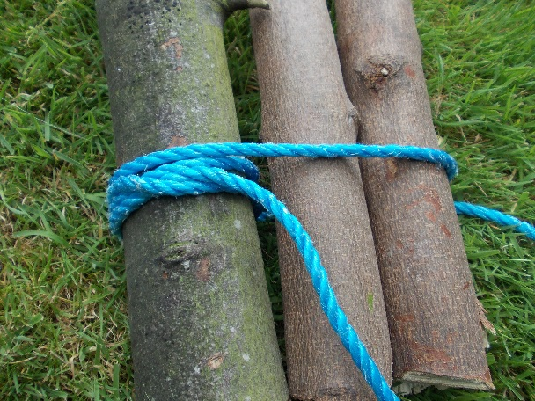

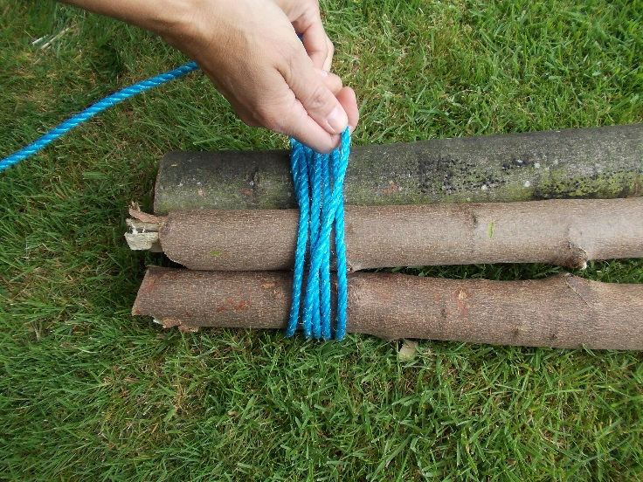

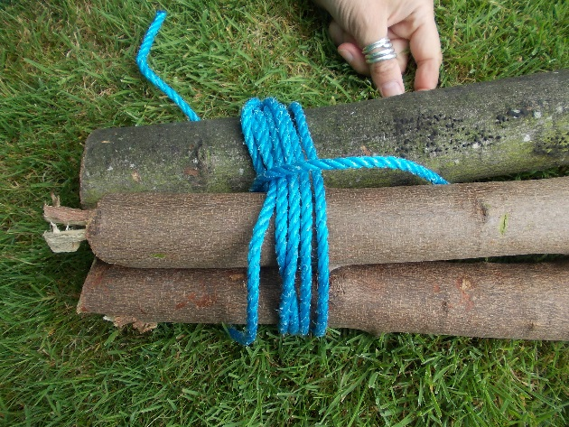
Frap in between the poles to tighten the rope.
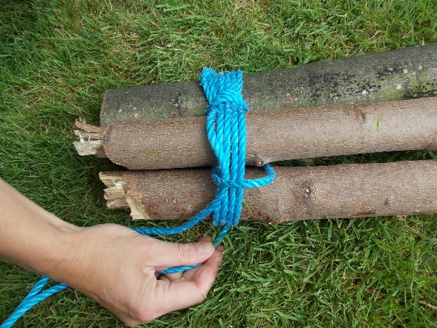

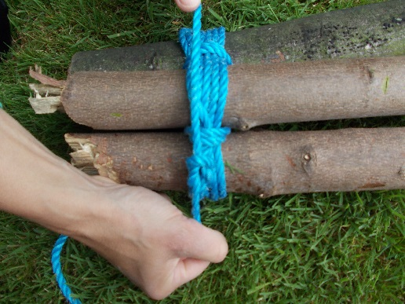
Finish with a knot

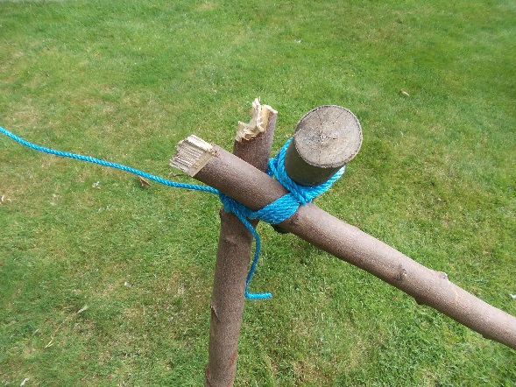
The poles can then be spread out to make a tripod.
Bh

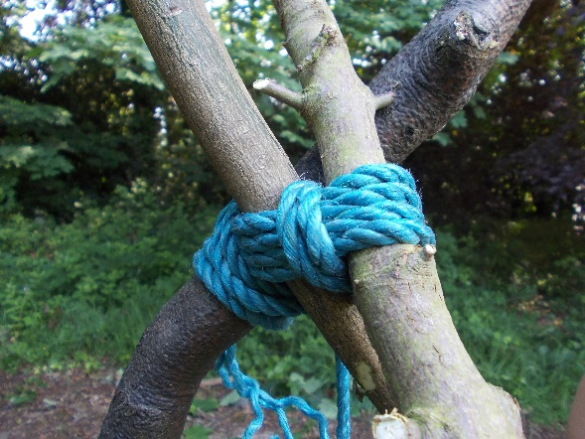

Tripods can be used to create a frame for a den for yourself or for a “Forest Pixie” hideout.
Have Fun!
Stay Safe!

