Artist of the month
April
Frida Kahlo
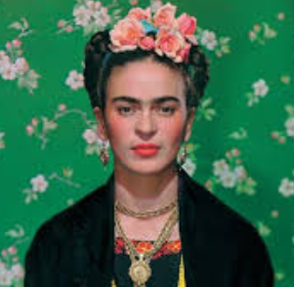

Frieda Kahlo was a famous Mexican artist. When she was young she was involved in an accident and as part of her recovery she would paint. She spent a long time indoors and as a result painted her self-portrait lots of times.
Things to do
Find out about Frieda and have a look at her work. You could use the websites below:
https://thekidshouldseethis.com/post/frida-kahlo-the-woman-behind-the-legend
https://www.lottie.com/blogs/strong-women/frida-kahlo-biography-for-kids
https://kidworldcitizen.org/kids-learn-frida-kahlo-mexican-artist-extraordinaire/
What do you like? What don’t you like? Have a go at drawing your own self- portrait. You could also do portraits of other members of your family. It would be lovely to see your work so if possible send examples to your teacher.
Have fun and be creative!

