Fluent in Five 20/03/20
- What is the difference between 3 and 6
- 57, 56, 55, ___, ____, ____
- 86 _____ tens _____ ones
- 1 more than 46 ____. 1 less than 58 ____
- 10 more than 25 ___. 10 less than 37 ____
Something from last year:  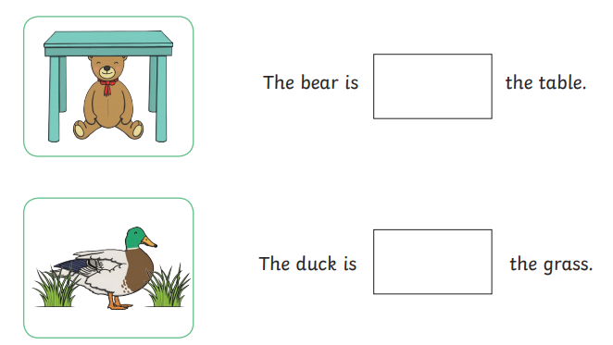 | 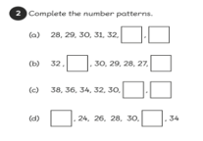  Something from last term:
Something from current chapter  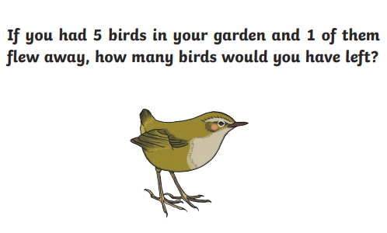 | Something from last week:  Write in numbers  3 tens ______  1 ten and 5 ones _____  2 tens and 4 ones ____  3 tens and 6 ones _____

