WELL-BEING NEWSLETTER
|
April 2020
PARENT/CARER Issue 2

 | 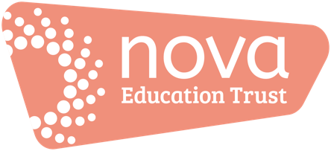 | Welcome to the second issue of our ‘Work Hard; Be Kind; Well-being’ newsletter!  There’ll be an issue of this newsletter at the end of each month until the end of this academic year (July).  This is your ‘one-stop-shop’ for information and resources to support you during this period.  Please also see our newsletters for pupils and parents/carers in addition to this one for you.  01. Keeping on top of your ‘well-being’  - Click the image to watch:  Try some stretches at the beginning or throughout the day:  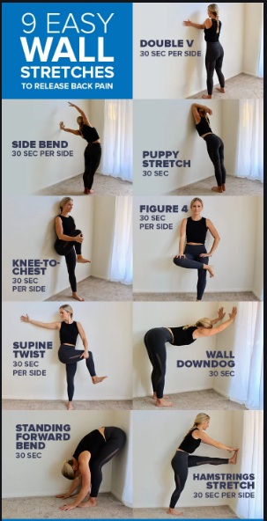  02. Information, guidance and updates  Government response to COVID-19 – this includes the latest announcements and guidance/information/announcements to date https://www.gov.uk/government/topical-events/coronavirus-covid-19-uk-government-response  - Here are the details for the DfE coronavirus helpline:  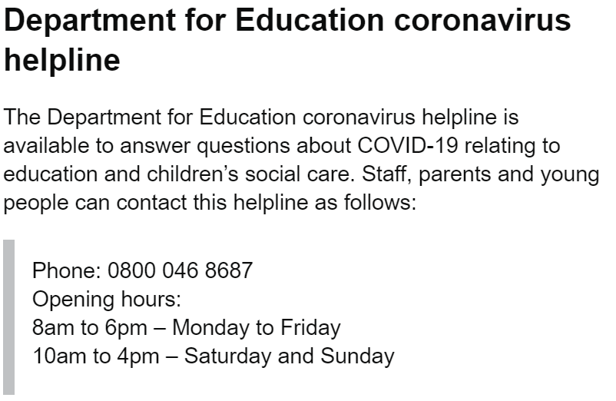  03. Support  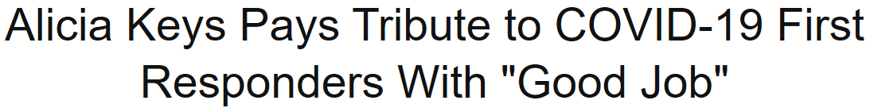  Click the image to listen  Directory:  - The Samaritans offer emotional support 24 hours a day - in full confidence. Call 116 123 - it's FREE or email jo@samaritans.org.uk - https://www.samaritans.org  - https://www.mind.org.uk/  - https://www.nhs.uk/  - https://youngminds.org.uk/find-help/for-parents/parents-helpline/  Supporting children:  - Supporting children to cope without school https://www.bbc.co.uk/news/uk-politics-51959957  - Talking to children about world news https://www.mentalhealth.org.uk/publications/talking-to-your-children-scary-world-news  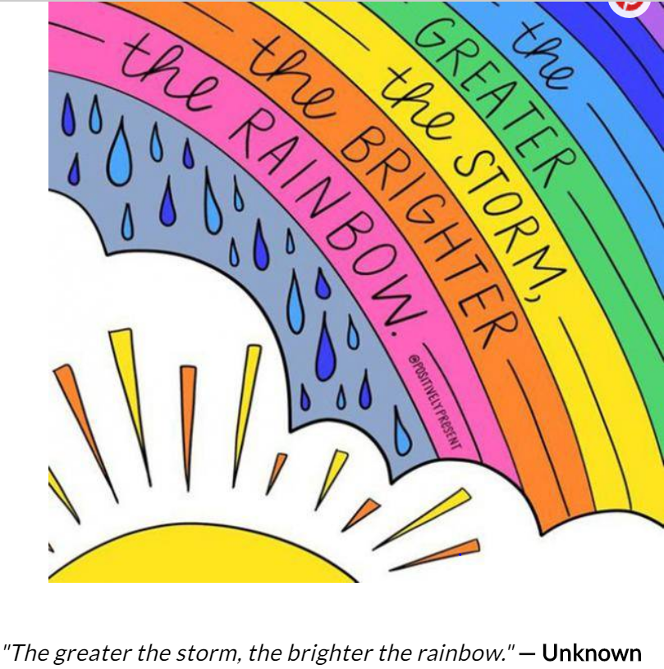  Supporting ourselves:  - Looking after your own mental health during this period:  https://www.mentalhealth.org.uk/publications/looking-after-your-mental-health-during-coronavirus-outbreak  - Well-being https://www.mind.org.uk/information-support/coronavirus-and-your-wellbeing  - Working from home suggestions (Mental Health First Aid England, https://mhfaengland.org)  04. Activities and resources  - Jugar Life is a free App to sign up to; again, focusing on well-being.  Click on the image:  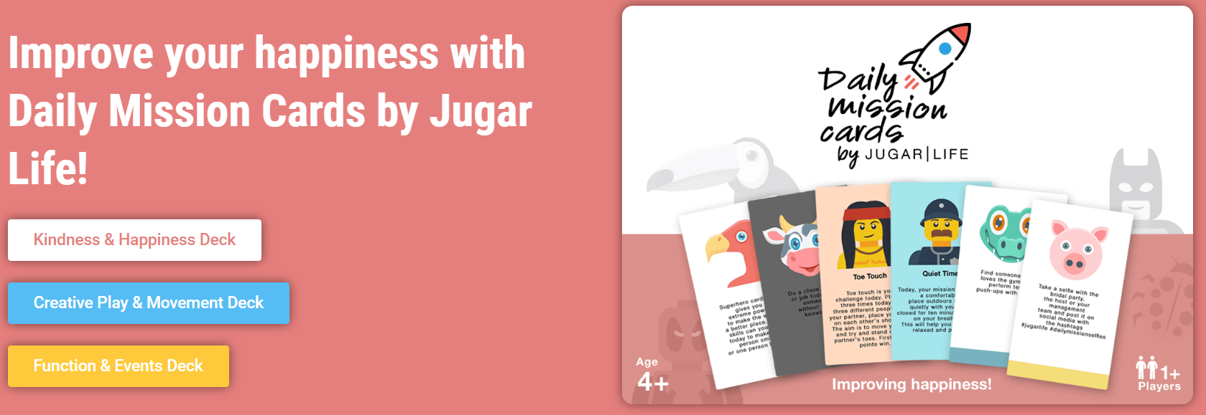  For you and for families  - Activities for you to try at home with your family. Click on the image:  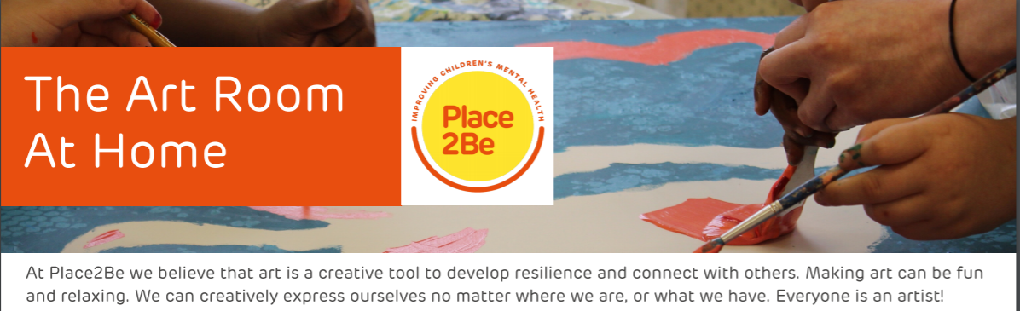  05. ‘Here’s one I tried earlier’  This is where we’ll share your ideas, tips and suggestions. This could include: a recipe to try; suggestions for in-door sports and games; arts and crafts activities; ways in which you’ve used an activity or resource from this newsletter and your ‘top tips’ for doing it; any ideas that you’ve had from your experiences so far. All ideas, tips and suggestions will be curated by our team and published anonymously.  If you’ve got suggestions for ‘Here’s one I tried earlier’, please email Well-Being@novaeducationtrust.net  - Take a listen and just enjoy – you deserve it:  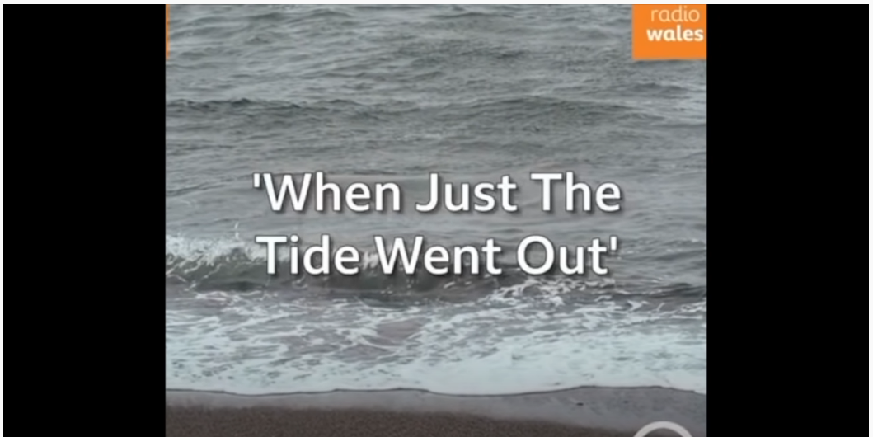
- Keeping on top of your ‘well-being’

- Information, guidance and updates

- Support

- Activities and resources

- ‘Here’s one I tried earlier’

