Dough Disco
In Nursery we introduced a 5 minute dough disco session three times a week. Dough disco is a fun activity with several hand and finger exercises designed to develop fine motor skills and hand/eye co-ordination. This is an activity which you can do together at home. All you need is some playdough and some music to move along to. (Look for links on you- tube)
Activity
Choose a hand – Say hello to each finger/thumb.
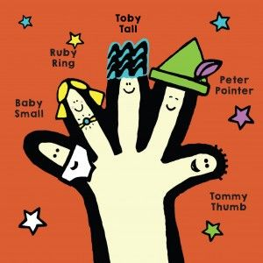
Hello – Tommy thumb
Peter pointer
Tommy tall
Ruby ring
Baby small

“We are going to take you to the dough disco”. Get your dough and let’s go”.

Roll it into a ball, roll it into a sausage. Squeeze it, pat it , flatten it, poke it, pinch it.

Have lots of fun together and remember to take some photographs.

