Rhymes of the week -8.6.2020
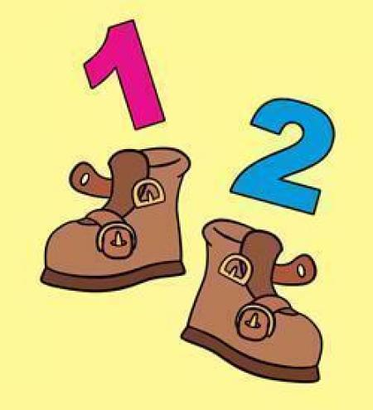
1,2, Buckle my shoe.
1,2 buckle my shoe.
3,4 knock on the door.
5,6 pick up sticks.
7,8 lay them straight.
9,10 a big fat hen.
(or 9,10 let’s do it again)

Pattern rhyme
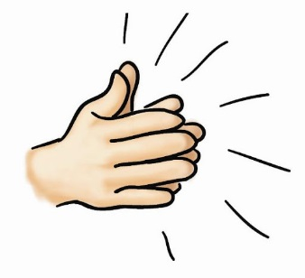
Clap your hands and wiggle your fingers.
Clap your hands and wiggle your fingers.
Clap your hands and wiggle your fingers.
Now we’ve made a pattern.

Repeat with two different actions.

Counting rockets.
If you have a number line or number cards use them to refer to as you do this activity.
Pretend to be a rocket going to the moon. Count forwards 0-10 and backwards 10-0.
When your child is confident counting forwards and backwards from 0 start on different numbers. For example 5 -10.

