Ladybird Ladybird 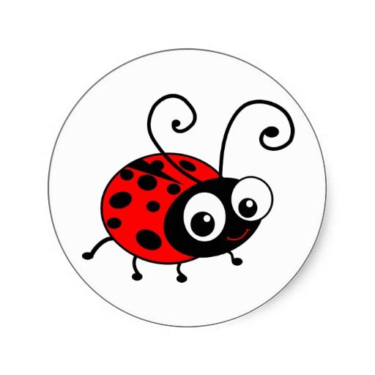
Ladybird Ladybird fly out of the farm,
and land right onto my little arm.
Ladybird Ladybird fly out of the tree,
and land right onto my little Knee.
Ladybird Ladybird fly out of your bed,
and land right onto my little head.
Ladybird Ladybird fly out of the rose,
And land right onto my little nose.

