WELL-BEING NEWSLETTER
|
April 2020
PUPIL Issue 2

 | 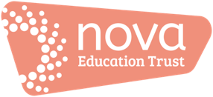 | Welcome to the April issue of our ‘Work Hard; Be Kind; Well-being’ newsletter!  There’ll be an issue of this newsletter at the end of each month until the end of this academic year (July).  This is your ‘one-stop-shop’ for information and resources to support your time out of school.  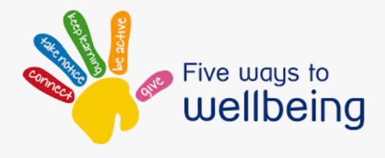  01. What is ‘well-being’?  It’s a term we hear a lot but what does it mean?  Dictionary definitions tell us that it’s about comfort, health and happiness. Essentially, it’s about our emotional as well as our physical health: keeping our minds and our bodies healthy!  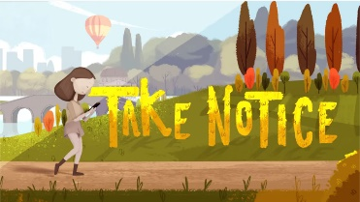  Here’s a short video which might give you some ideas about what ‘well-being’ means https://www.youtube.com/watch?v=oSIWo5nxF2A and another one with ideas for how you could develop yours:  https://www.youtube.com/watch?v=yF7Ou43Vj6c. Aimed at children but applicable to adults, too!  0.2 Support  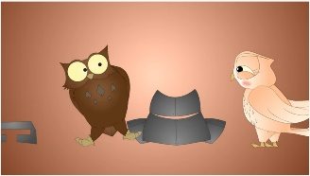  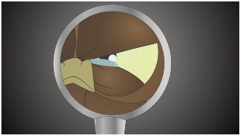  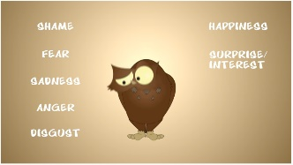  Are you feeling okay? How do you know if you are or not? Click on: https://www.youtube.com/watch?v=CtiO3aF79cU to watch a video to help you understand…  Other links you might find helpful too:  - https://www.childline.org.uk/  - https://www.annafreud.org/on-my-mind/youth-wellbeing/  - https://youngminds.org.uk/find-help/for-parents/parents-helpline/  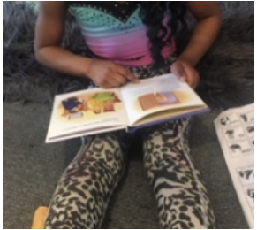  0.3 Information, guidance and updates  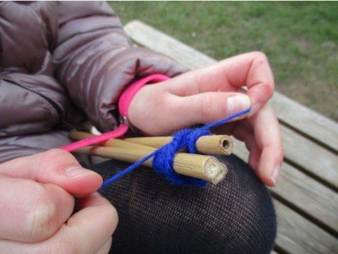  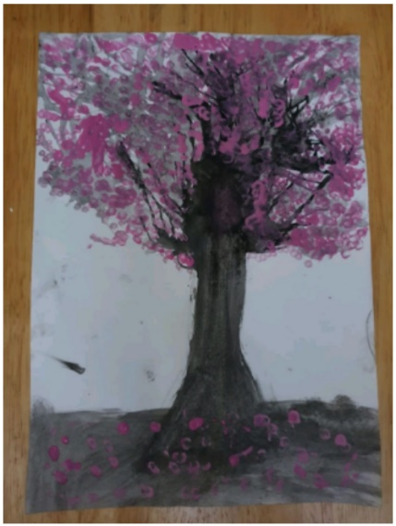  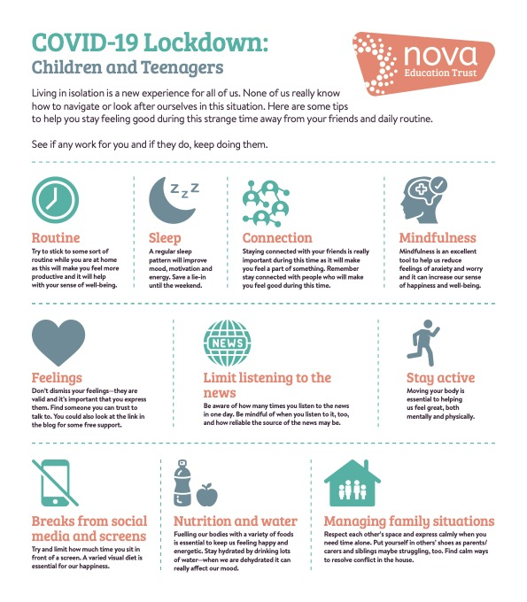  04. Special Activities  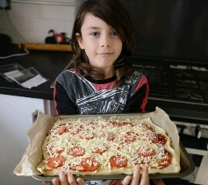  - Try baking a pizza – what toppings do you like? Are you a pineapple or no pineapple type of pizza-eater??  - Love music? How about trying to beatbox? Click here for your first session. Enjoy!  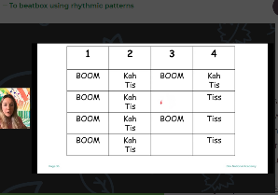  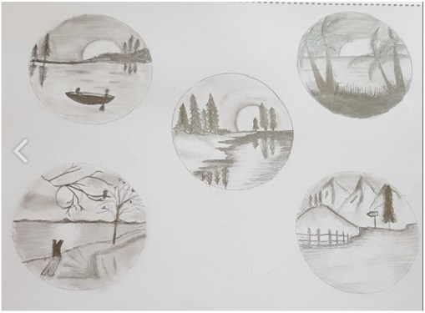  05. Activities and resources  - Continue to keep active every day with the fab Joe Wickes. Click here.  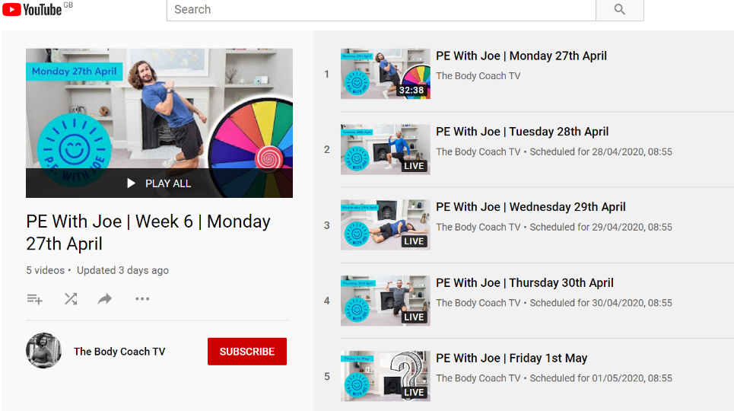  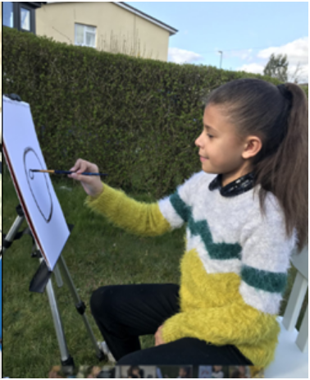  - Can you write 3 top tips for doing your favourite exercise correctly and safely?  - Would you like to reminisce? Click for a happy memory curtesy of Miss Potter…  06. ‘Here’s one I tried earlier’  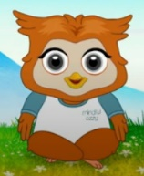  This is where we share your ideas, tips and suggestions.  - Meet Mindful Ozzy! Click here to join Mindful Ozzy in  practising his mindfulness superpower in keeping  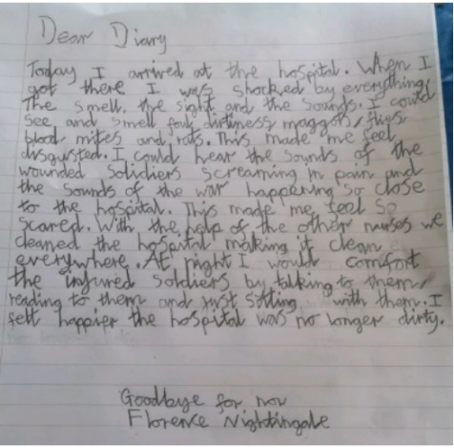  calm and relaxed  If you’ve got suggestions for ‘Here’s one I tried earlier’, please email Well-Being@novaeducationtrust.net  All ideas, tips and suggestions will be curated by our team and published anonymously. This could include: a recipe to try; suggestions for in-door sports and games; arts and crafts activities; ways in which you’ve used an activity or resource from this newsletter and your ‘top tips’ for doing it; any ideas that you’ve had from your experiences so far.  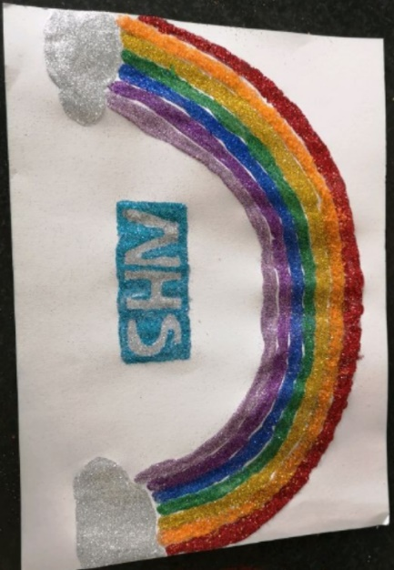  Thank you NHS workers  Contact us  The main contact email to use for your school for general enquiries is [admin@firbeck.org.uk]
- What is ‘well-being’?

- Support

- Information, guidance and updates

- Special features

- Activities and resources

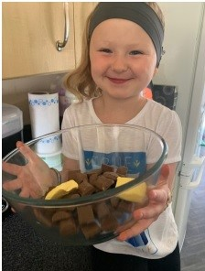
- ‘Here’s one I tried earlier’

