WELL-BEING NEWSLETTER
|
July 2020
PARENT CARER Issue 5

 | 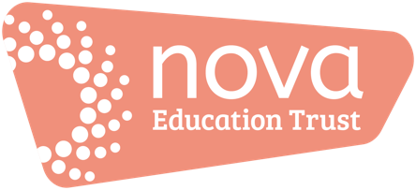 | Welcome to the final issue of our ‘Work Hard; Be Kind; Well-being’ newsletter!  We hope that you have enjoyed and found the newsletters helpful. We wish you all a great relaxing and safe summer, and look forward to seeing you all in September.  - Listen to Firbeck’s latest video on the school website:  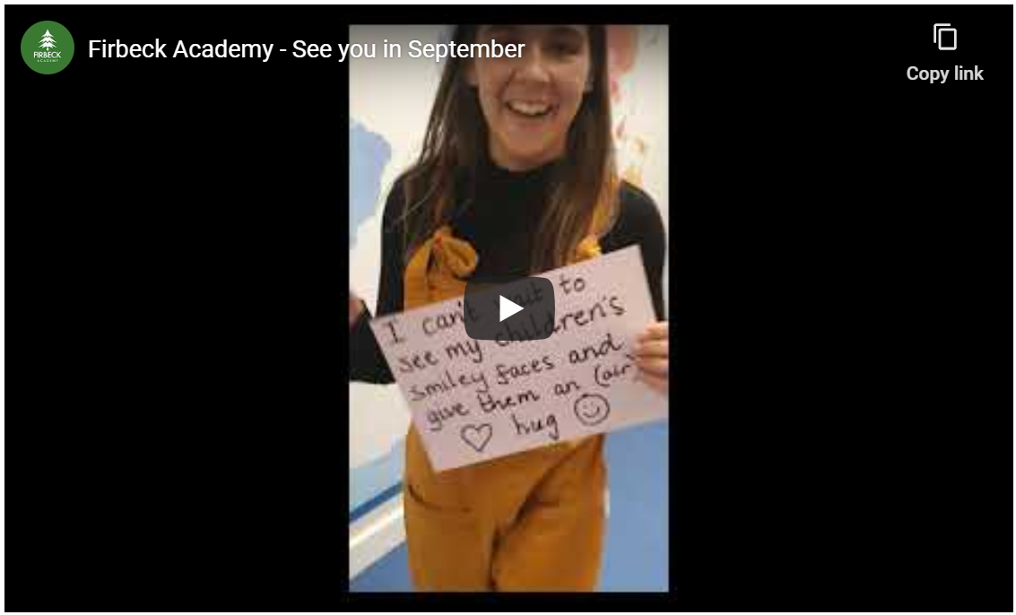  01. Keeping on top of your and your child’s ‘well-being’  - Click the link to be redirected to tips for nurturing your child’s mental health:  https://www.caringforkids.cps.ca/handouts/mental_health  Click the link to be redirected to tips that will ensure your mental health and well-being is looked-after:  https://www.mhe-sme.org/covid-19/  02. Information, guidance and updates  Government response to COVID-19 – this includes the latest announcements and guidance/information/announcements to date https://www.gov.uk/government/topical-events/coronavirus-covid-19-uk-government-response  Click here if you need to book a Covid-19 test:  https://www.nhs.uk/ask-for-a-coronavirus-test  03. Support  Click here for links to various mental health services:  https://www.nhs.uk/using-the-nhs/nhs-services/mental-health-services/dealing-with-a-mental-health-crisis-or-emergency/  Directory:  - The Samaritans offer emotional support 24 hours a day - in full confidence. Call 116 123 - it's FREE or email jo@samaritans.org.uk - https://www.samaritans.org  - https://www.mind.org.uk/  - https://www.nhs.uk/  - https://youngminds.org.uk/find-help/for-parents/parents-helpline/  04. Activities and resources  - Support for parents with homeschooling:  https://www.hellomagazine.com/healthandbeauty/mother-and-baby/2020032286679/educational-apps-websites-homeschooling-coronavirus/  A mountain of resources here:  https://literacytrust.org.uk/family-zone/  5 simple activities to promote mindfulness with your children:  https://www.mindfullittleminds.com/5-fun-and-easy-mindfulness-crafts-your-kids-will-love/  05. ‘Here’s one I tried earlier’  Get your brain working by trying this quiz (answers at the bottom!):  https://www.edinburghnews.scotsman.com/whats-on/arts-and-entertainment/25-funny-pub-quiz-questions-2020-hilarious-and-quirky-trivia-ask-your-virtual-quiz-plus-answers-2540427  An easier (more fun!) one for you:  https://www.cosmopolitan.com/uk/worklife/a32401351/best-easy-quiz-questions/
- Keeping on top of your and your child’s ‘well-being’

- Information, guidance and updates

- Support

- Activities and resources

- ‘Here’s one I tried earlier’

