WELL-BEING NEWSLETTER
|
June 2020
PARENT/CARER Issue 4

 | 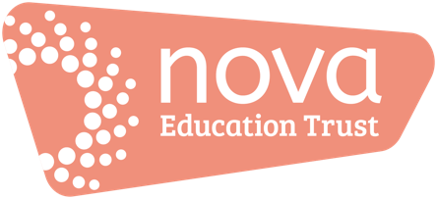 | Welcome to the second issue of our ‘Work Hard; Be Kind; Well-being’ newsletter!  There’ll be an issue of this newsletter at the end of each month until the end of this academic year (July).  This is your ‘one-stop-shop’ for information and resources to support you during this period.  Please also see our newsletters for pupils in addition to this one for you.  01. Keeping on top of your ‘well-being’  - Click the image to be directed to psychcentral.com’s tips for well-being:  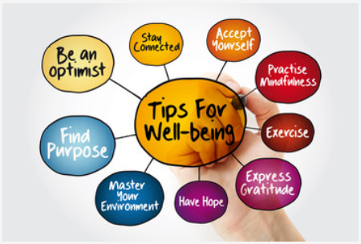  More tips to gain better mental well-being – click on the image for more information from the NHS:  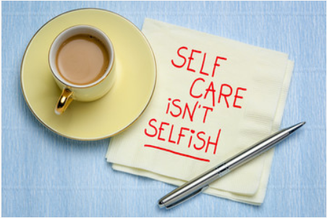  A short video on 5 ways to wellbeing:  https://www.youtube.com/watch?v=LCA4EEyCBCE  02. Information, guidance and updates  Government response to COVID-19 – this includes the latest announcements and guidance/information/announcements to date https://www.gov.uk/government/topical-events/coronavirus-covid-19-uk-government-response  Click here if you need to book a Covid-19 test:  https://www.nhs.uk/ask-for-a-coronavirus-test  03. Support  Click here for links to various mental health services:  https://www.nhs.uk/using-the-nhs/nhs-services/mental-health-services/dealing-with-a-mental-health-crisis-or-emergency/  Directory:  - The Samaritans offer emotional support 24 hours a day - in full confidence. Call 116 123 - it's FREE or email jo@samaritans.org.uk - https://www.samaritans.org  - https://www.mind.org.uk/  - https://www.nhs.uk/  - https://youngminds.org.uk/find-help/for-parents/parents-helpline/  04. Activities and resources  - https://www.bbc.co.uk/bitesize/articles/znsmxyc  05. ‘Here’s one I tried earlier’  Sew yourself to well-being: Read this blog in 3 minutes -  If you’ve got suggestions for ‘Here’s one I tried earlier’, please email Well-Being@novaeducationtrust.net
- Keeping on top of your ‘well-being’

- Information, guidance and updates

- Support

- Activities and resources

- ‘Here’s one I tried earlier’

