WELL-BEING NEWSLETTER
|
June 2020
PUPIL Issue 4

Welcome to the April issue of our ‘Work Hard; Be Kind; Well-being’ newsletter!
There’ll be an issue of this newsletter at the end of each month until the end of this academic year (July).
This is your ‘one-stop-shop’ for information and resources to support your time out of school.

01. What is ‘mental health and well-being’?
It’s a term we hear a lot but what does it mean?
Dictionary definitions tell us that it’s about comfort, health and happiness. Essentially, it’s about our emotional as well as our physical health: keeping our minds and our bodies healthy!
Here’s a short video which ‘talks mental health’… https://www.youtube.com/watch?v=nCrjevx3-Js

0.2 Support
Click here for a range of support - https://www.childline.org.uk/
If you can’t sleep – https://www.childline.org.uk/get-involved/articles/5-tips-to-help-you-get-to-sleep/?in_type=articlecontent
If you feel anxious - https://www.childline.org.uk/info-advice/your-feelings/anxiety-stress-panic/
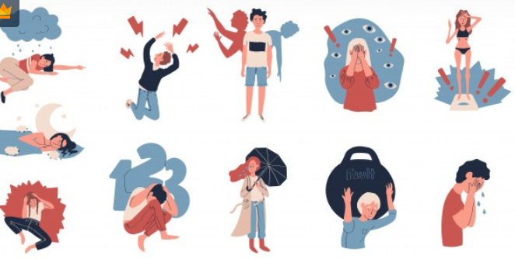

https://www.mind.org.uk/information-support/for-children-and-young-people/
https://www.childline.org.uk/get-support/contacting-childline/

0.3 Information
https://www.bbc.co.uk/newsround
https://www.bbc.co.uk/iplayer/episode/m000kl33/newsround-30062020
https://www.bbc.co.uk/programmes/b01s2dct
https://www.bbc.co.uk/newsround/51318780

04. Activities

- Try writing a diary and including how you feel and why. Then try and have a few moments thinking about what you could do to help you feel happier or calmer and jot them down in a list like this:
- Read more picture books.
- Practise breathing in and out (without any interruptions if possible).
- Try to calm down before I say something I might regret – count to 10 or breathe deeply if I feel like I’m getting angry.
- Try to think positively for 5 minutes every day for example, I have a loving family, I have a garden to play in, I have friends that are kind to me etc.
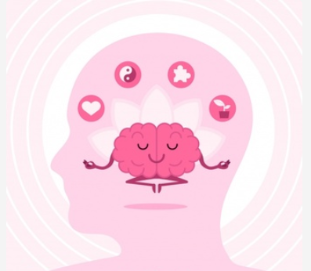

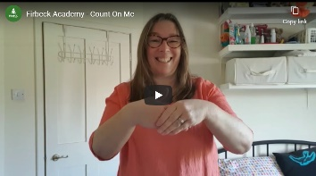
- Listen to Firbeck’s signed song on the school website:

Contact us
The main contact email to use for your school for general enquiries is [admin@firbeck.org.uk]

- Talking mental health and well-being… what is it?

- Support

- Information

- Activities

