Learning Project WEEK 6: Food
Age Range: KS1
Learning Project - to be done throughout the week: Food
Food
The project this week aims to provide opportunities for your child to learn more food. Learning may focus on where different foods originate from, what makes a healthy meal, opportunities to cook etc .

Balanced diet: Show your child this video about how to have a balanced diet.

Play these games about healthy eating.
What do we have today? Look in the kitchen to see if you can create an A-Z list of foods.

Fruit and vegetables - Draw pictures of fruit and vegetables in your house. Label the fruit and vegetables and place in alphabetical order.

Sorting activity: Collect food from the kitchen and sort into healthy and unhealthy foods.

Design a poster - think about the foods you like to eat and food that you need to eat to keep you healthy. Create a poster that you can put in the kitchen or in the school hall. Will you be able to use any food wrappers or make your poster interactive?

Healthy lunchbox: can you play this game and make a healthy lunchbox?

Traditional food: Many cultures have various dishes of food to celebrate their festivals. Find out about a festival and compare it to a different festival. What are the similarities? What are the differences? How is the food prepared? Do you have any traditional food you enjoy with your family?

Restaurant: Can you plan a menu? Think about what you would like to have on your menu. Can you design a menu for a vegetarian? Can you design a menu for a vegan? Will you have options on your menu for people who have allergies?
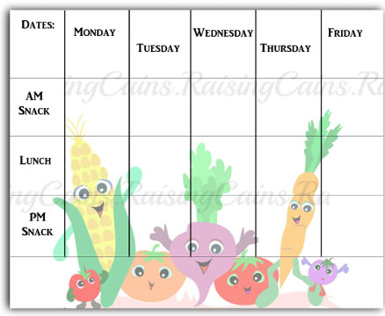
Look around the house for any leaflets or take away menus. What price is the food? Can you do any meal deals?

Designing a school menu. Can you design a new school menu? What could you add? What would you keep the same? Will it be a healthy school menu? Can you find pictures or draw pictures to add to your menu? Plan out your menu and remember to include prices.
Will you have a different menu everyday?

Cooking: find a few recipes and check if you have the ingredients at home and cook a meal for your family. Think about a starter, main and dessert. Can you cook as a family? Who will do the measuring?

Fruit survey: ask in your family the different fruits they like to eat. Collect the information and add it to your tally chart. Can you represent this information in a particular way?
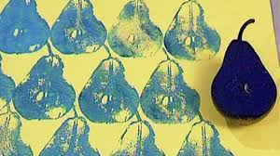
Fruit and vegetables printing: Look at the work of the artist: Lynn Flavell. How does she represent fruit and vegetables? Can you create a piece of artwork in the style of Lynn Flavell.

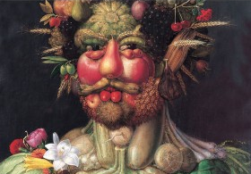
Look at the work of Giuseppe Arcimboldo.
Using different drawing materials, can you create a picture of your own?
Additional learning resources parents may wish to engage with
Classroom Secrets Learning Packs - These packs are split into different year groups and include activities linked to reading, writing, maths and practical ideas you can do around the home.
Twinkl - to access these resources click on the link and sign up using your own email address and creating your own password. Use the offer code UKTWINKLHELPS.
Headteacherchat - This is a blog that has links to various learning platforms. Lots of these are free to access.
#TheLearningProjects

