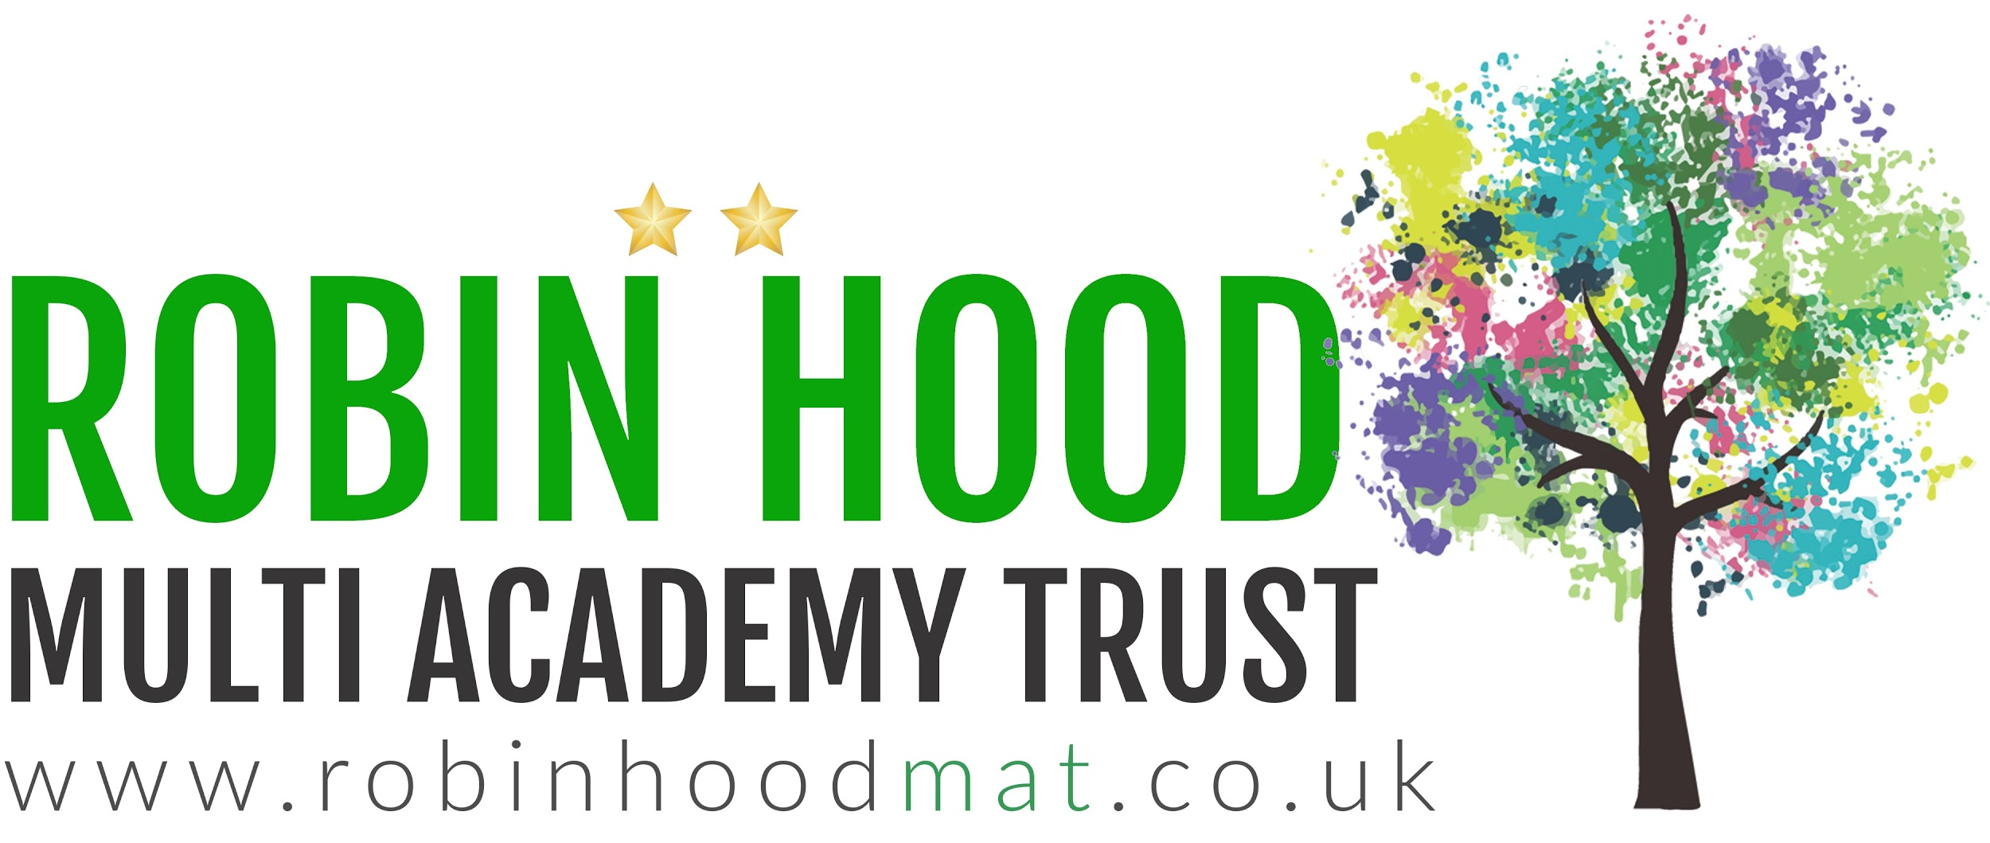

Learning Project WEEK 7 - Celebrations
Age Range: Y3/4
Learning Project - to be done throughout the week
This project this week aims to provide opportunities for your child to learn more about celebrations. Learning may focus and different types of celebrations that take place and who may celebrate them. It could look at how people celebrate different events differently in other parts of the world.

- Let’s Wonder:

How are birthdays celebrated around the world? India China America Africa etc.. maybe
there's a particular country they would like to find out about. Create fact files to show the
similarities and differences between them.
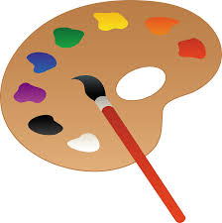
- Let’s Create:

Create a board game that focuses on celebrations. Think about what they can learn from it? Think about how to play the game. Is it going to be a game like Monopoly or Snakes and ladders? Are they going to need a dice? Cards? Characters? etc….

- Be Active:

Why not play a game of hopscotch? Can’t find any chalk? Use a stone from the garden. Raining? Build an indoor den and have an imaginary celebration with their toys.
Recommendation at least 2 hours of exercise a week.

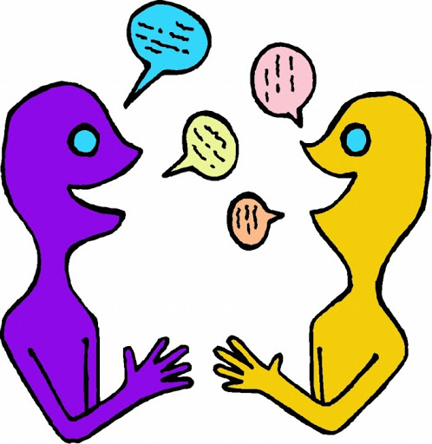
- Time to Talk:

Look through old photos of previous celebrations them and their family have taken part in. What can they remember happened? Why do they and their families celebrate the way they do?

- Understanding Others and Appreciating differences:

How many different types of celebrations are there? Who celebrates Christmas? St Patricks? St George? St David? Easter? Eid? Diwali? Chinese new year? And how? Which celebrations have they taken part in? What usually happens?

Additional learning resources parents may wish to engage with
Classroom Secrets Learning Packs - These packs are split into different year groups and include activities linked to reading, writing, maths and practical ideas you can do around the home.
Twinkl - to access these resources click on the link and sign up using your own email address and creating your own password. Use the offer code UKTWINKLHELPS.
Headteacherchat - This is a blog that has links to various learning platforms. Lots of these are free to access.
#TheLearningProjects

