Summer Term 2019: The Forces of Nature | Year: 4 | Teacher: Mr Edwards
Curriculum Map
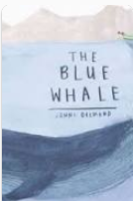  Some of our Class Texts this Term:  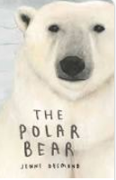  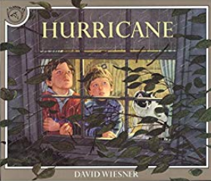 | This term, will be learning about...  - How people and animals around the world are threatened Natural disasters.  - We will look in detail at natural phenomena and develop an understanding of how how efforts to end climate change and using technology we can protect ourselves, our homes and species at risk of extinction. | English  Over the course of this term we will be looking closely at the following texts: ‘The Blue Whale’ and ‘The Polar Bear’ by Jenni Desmond – two fantastic non-fiction books all about these fascinating endangered species. We will also be writing nature descriptions using ‘Hurricane’ by David Wisner as inspiration.  We will also continuing to focus really hard to develop our handwriting and presentation skills in every lesson.  Spellings will be sent home each Friday to ensure Year 4 level spellings are practiced regularly. There will be a test the following Friday. | Mathematics  This half term our maths is focusing on Measurement.  Mass, Volume and Length  Children will learn how to estimate and measure mass, volume and length. They will learn how to convert units of measure from larger to smaller and vice versa. Pupils will also be taught how to measure perimeter using centimetres and millimetres. They will use their knowledge of measures to solve problems involving all three aspects of measurement  Area and Perimeter  Children ill learn about the concepts of area and perimeter. They will measure area finding areas of figures that have squares and rectangles by counting and visualising. They will learn how to apply their knowledge of finding area to figures in different orientations.  After half term we will be Decimals, Money and Measurement
The Firbeck Curriculum will:  F – Make learning FUN.  I – Develop INDEPENDENCE.  R – Put positive RELATIONSHIPS at the centre of all we do.  B – Make children BOLD and BRAVE, able and willing to take risks.  E – Develop ENQUIRY and the thirst for learning new things.  C – Develop children who appreciate and value their own and others’ CULTURES.  K – Provide KNOWLEDGE, empowering children to be anything they dream of being. | Geography  We will be studying what makes a disaster natural and asking ourselves what are the causes and effects of natural disasters?  This half term we will look in detail at, Tsunamis, Earthquakes, Hurricanes, Floods and Volcanic Eruptions.  After half term we will study how climate change is increasing the likelihood of natural disasters.  What causes them?  Where are they most common?  Effects  Give a details of a well-known examples  How do/can people in affected areas protect themselves?
 | Science  In Science we will be learning about ‘All Living Things’ and understanding that living things can be grouped in a variety of ways.  We will be exploring and use classification keys to help group, identify and name a variety of living things in their local and wider environment. We will be making links by understanding how climate change and natural disasters can affect all living things around the planet. | Computing  Children will be developing their knowledge of coding by designing and making our own natural disaster based computer game ‘Tsunami Charlie’ using SCRATCH programming.  RE/PSHE  Children will be exploring wellbeing and meditation through YOGA with links to Buddhism and Hinduism | OUR FINAL DESTINATION:  This Half Term we will be creating a Class Book in the style of Jenni Desmond to contain Animal Reports with a focus on species endangered through climate change.  After half term we hope to visit the local community to see how we can spread the word of climate change to ensure a safer world for generations to come!  .

