Spring Term 2019: The ‘Angry’ Aztecs | Year: 4 | Teacher: Mr Edwards
Curriculum Map
Some of our Class Texts this Term:  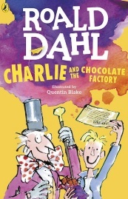  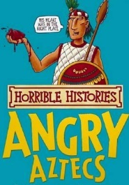  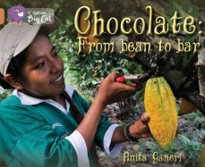 | This term, we will make memories by….  - Taste testing Chocolate  - Designing and manufacturing our very own chocolate product  - Learning all about the Aztec Civilisation and making our own Aztec shields, sunstones and headdresses!  - Visiting Cadbury’s World | English  Over the course of this term we will be looking closely at the following texts: ‘The Chocolate Touch’, ‘Chocolate: From Bean to Bar’, and of course ‘Charlie and the Chocolate Factory’!  We will also be focusing really hard to develop our handwriting and presentation skills in every lesson.  While we will always be developing our spelling and grammar skills, our writing will be focussed on writing for different purposes  Things like:  - Fact files about the Aztecs and chocolate using our own research  - Describing sweetshop settings  - Creating persuasive chocolate adverts | Mathematics  This half term our maths is focusing on Fractions and Time.  Fractions  Children will learn about mixed number fractions and improper fractions. They will learn how to convert between mixed numbers and improper fractions. They will learn how to add and subtract fractions and will solve addition and subtraction word problems.  Time  Children will learn about the 24-hour clock. They will learn how to use both the 12-hour clock and the 24-hour clock. They will convert between units of time, such as minutes and seconds, and hours and minutes.  After half term we will be Decimals, Money and Measurement
The Firbeck Curriculum will:  F – Make learning FUN.  I – Develop INDEPENDENCE.  R – Put positive RELATIONSHIPS at the centre of all we do.  B – Make children BOLD and BRAVE, able and willing to take risks.  E – Develop ENQUIRY and the thirst for learning new things.  C – Develop children who appreciate and value their own and others’ CULTURES.  K – Provide KNOWLEDGE, empowering children to be anything they dream of being. | History  We will be finding out about the Aztecs in topic including where and when they lived, the city of Tenochtitlan, Aztec society and beliefs and the daily lives of the Aztecs. We will also be exploring a plant native to the Aztec region – the Chocolate Bean!
 | Science  In Science we will be learning how to sort materials into solids, liquids and gases. Explain that heating causes melting, and cooling causes freezing – with a particular focus on the different states of chocolate! | eSafety:  Children will be developing their knowledge of how to be a responsible Digital Citizen in Computing by understanding the importance of security and privacy on the internet and how to keep themselves safe when using technology.  R.E.  In RE, we will be learning about Buddhism. | OUR FINAL DESTINATION:  We will also be designing our own chocolate brand and making our own chocolate.  We will also going to make our own  Aztec shields  Aztec Sunstones and  Aztec Headdresses in Art & Design  Y3 and 4 hope to visit Cadbury’s World this term.

