Autumn Term 2018 | Year: 4 | Teacher: Mr Edwards
Curriculum Map
Two of our Class Texts this Term:  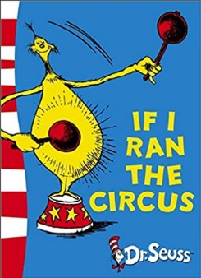  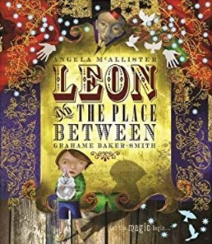 | This term, we will make memories by….  - Having a family film night of the ‘Greatest Showman’  - Learning circus skills like juggling  - Having a Circus day, where people come in to teach us all about the circus | English  Over the course of this term we will be looking closely at the following texts: ‘The Dancing Bear’, ‘Leon and the Place Between, If I Ran The Circus and ‘The Man Who Walked Between the Towers’  We will also be working really hard to develop our handwriting and presentation skills in every lesson.  While we will always be developing our spelling and grammar skills, our writing will be focussed on writing to entertain and writing to inform.  Things like:  - Circus themed fantasy stories  - Advertisements for Circuses  - Information Texts relating to our topic  - Circus themed poetry  - Circus performance Instructions | Mathematics  We will be consolidating our knowledge in Year 4 by learning about:  - Place Value  - Addition/ Subtraction and Multiplication/ Division  - Fractions  - Geometry-position and direction  A crucial part of our daily maths work will be learning all of the times tables up to 12x12. Please encourage times table practice at home too!  A really important part of the study of Maths is also Reasoning. This is the ability to explain why we do things in a certain way to solve problems –for example explaining how you found an answer using mathematical language.
The Firbeck Curriculum will:  F – Make learning FUN.  I – Develop INDEPENDENCE.  R – Put positive RELATIONSHIPS at the centre of all we do.  B – Make children BOLD and BRAVE, able and willing to take risks.  E – Develop ENQUIRY and the thirst for learning new things.  C – Develop children who appreciate and value their own and others’ CULTURES.  K – Provide KNOWLEDGE, empowering children to be anything they dream of being. | Topic  We will be finding out about The History of the Circus in topic and identifying debating whether it was kind or cruel to have animals in the circus.  In PE, we will be learning a few circus skills and developing our gymnastics skills, such as rolls and balancing.  We will be learning about the art of LS Lowry finishing off with our own piece of Lowry inspired Circus Art.
 | STEM  In Science we will be learning how to light up the circus and create illusions in science, we will also be learning about forces and magnets.  In Computing we will be programming computers and making our own silent films.  In D&T we will be designing and making our very own juggling balls. | Well-being:  This is me!  Throughout our curriculum we will be identifying what is great about me, differences between each other and celebrating friendships and relationships.  In RE, we will be learning about the festivals of Rosh Hashanah (Judaism) ad Diwali (Hinduism). | OUR FINAL DESTINATION:  We hope that you can join is on:  Friday 14th December (pm)  We will be holding our very own exhibition of ‘This is Us’  This will also be an opportunity to share all of our super learning from Year 4 with parents.  There will also be work from across the school.

