Monday 8th January 2018

Dear Parents and Carers,

Happy New Year!

Welcome back after what I hope has been a good holiday for you and your family.

Our topic this term is ‘Birds!’ We will begin by reading a classic novel by Jill Thomlinson “The Owl who is afraid of the dark.” We hope to stimulate the children’s interest in our feathered friends in a variety of ways. More information will be sent as soon as possible on the different aspects of learning for this term.

PE will be on Tuesdays and Wednesdays for this half term. Please make sure that your child has their PE kit in school for these sessions.

Homework for Year 2 continues to be reading 5 times a week, spelling and times tables.
Times table will be tested on Thursday and spelling on Friday. Please continue to support your child at home with these activities.

As you can see there is a lot to do. It’s going to be another busy, busy, term!

Thank you for your support,

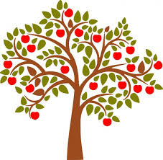
Karen Yeoman
Charlie Thomas

