Week Two 8.6.2020
Each day I will be introducing a new letter to the children. This week the letters are f,e,l,h and sh.
Monday 8.6.2020
Todays letter is f.
Say the sound - We call it a stretchy sound fffflower . (Keep teeth on bottom lip and force out air sharply.)
Say the rhyme together "Down the stem and draw the leaves" .Draw the letter in air with a magic pencil.
Look for objects beginning with the sound f.
Have a go at writing the letter f. Use crayons, pens, paint
---------------------------------------------------------------------------------------------------------------------------------
Activity - Fred talk - What's in the box.
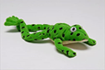
Find a box or bag. Use the four pictures below. ( You might have the objects in your house). Without your child seeing put an object in the box. Ask your child to listen carefully to the word/sounds in the word. Say word c-a- t. What is in the box? Repeat.
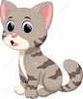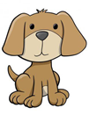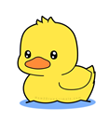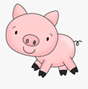
Click below for picture
Picture cards

Listen carefully to guess the sound
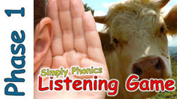

Farm animals
--------------------------------------------------------------------------------------------------------------------------------------
Tuesday 9.6.2020
Todays letter is
Say the sound.We call it a bouncy sound - e-e-e egg
Say the rhyme together "Lift off the top and scoop out the egg" .Draw the letter in air with a magic pencil.
Look for objects beginning with e. Have a go at writing the letter.
---------------------------------------------------------------------------------------------------------------------------------

Listening activity - Zoo animals.
Listen to the first part all about Zoo animals. Can you hear the monkey, tiger, sealion, donkey and elephant?
BBC - School radio - EYFS - Listening and attention sound game.
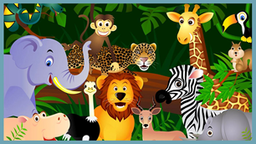
Click on the link - Listening game-Zoo animals
Which is your favourite Zoo animal?

Wednesday 10.6.2020
Todays letter is L.
Say the sound- LLL-Leg . (Keep pointed curled tongue behind teeth)
Say the rhyme together "Down the long leg" .Draw the letter in air with a magic pencil.
Look for objects beginning with L. Have a go at writing the letter.
Letter L sheet
Activity - Clapping the Syllables in a word.
This is a fun activity which teaches the children to say a word and to hear the syllables in the word. The children are all very clever at clapping the syllables in their name.
Have a go at clapping the minibeast names together.
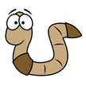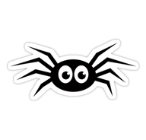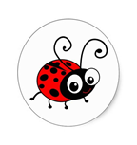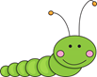

Worm spider Ladybird Caterpillar
1 clap 2 claps 3 claps 4 claps
Click on link for more minibeast names - Minibeasts

Thursday 11.6.2020
Todays letter is h.
Say the sound- This is a bouncy sound h -h- h- horse . (Say h as you breathe out sharply -unvoiced)
Say the rhyme together " Down the head to the hooves and over his back".Draw the letter in air with a magic pencil.
Look for objects beginning with h. Have a go at writing the letter.
Activity - Instrumental sounds.
Click on link- Instrumental sound activities
---------------------------------------------------------------------------------------------------------------------------------
Friday 12.6.2020
Todays letter is Sh.
I say to the children- In the picture I can see two letters. They are holding hands and it makes one sound. We call these special friends.
Say the sound -Shhhh ( Make a Shhh noise as if you are telling somebody to be quiet )
Say the rhyme together " Slither down the snake, down the head to the hooves and over his back".Draw the letter in air with a magic pencil.
Look for objects beginning with Sh. Have a go at writing the letter.

