Learning Project WEEK 6 - Food
Age Range: EYFS
Learning Project - to be done throughout the week
The project this week aims to provide opportunities for your child to learn more food. Learning may focus on where different foods originate from, what makes a healthy meal, opportunities to cook etc.
- Healthy/ Unhealthy-
  - Provide your child with a selection of items from your kitchen cupboards. Can they sort them into things that are healthy and unhealthy? Discuss why the food is good for you or bad for you. Look at the Eatwell plate to help figure out which foods they should eat a lot of or not very much of.

- Discuss how exercise is an important part of staying healthy. Watch and complete a 10 minute shake up.

- 5 a day-
  - Support your child to create a food diary to record how many pieces of fruit and vegetables they eat in a day. They could write these using their phonics knowledge or draw a picture of each item.

- Create a collage-
  - Ask your child to draw out a number of fruits or vegetables, large enough to fill a piece of A4 paper. Provide them with a selection of colourful packaging. Can they cut out and collage on to their picture to

- Play shops-
  - Using toy food or old packaging, set up a food shop for your child to act out being the shopkeeper and customer. You could introduce coins to support their developing knowledge of money. Give them a notepad to use as a shopping list to encourage in the moment writing.

- Potato/ Vegetable Printing-
  - Using a selection of vegetables available in your kitchen, support your child to print and explore the shapes and patterns created:
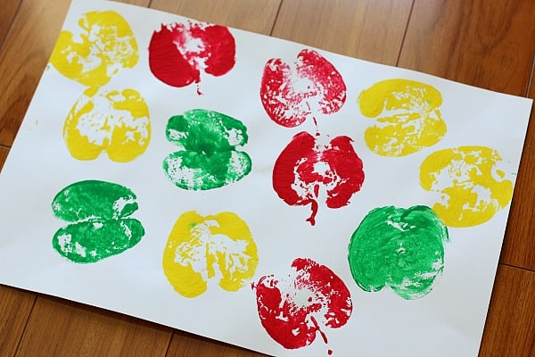
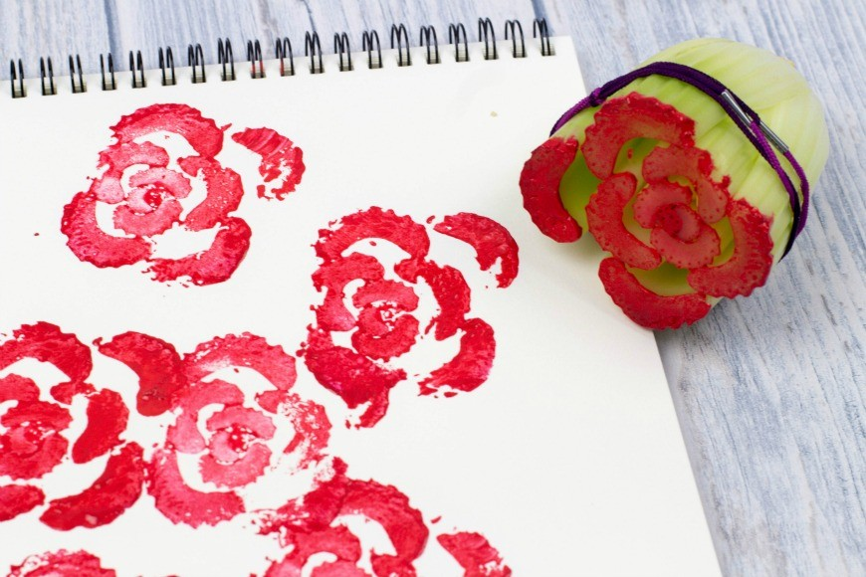
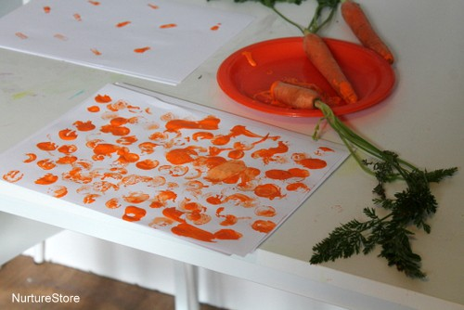

- Make cornflour gloop-
  - Mix cornflour with a small amount of water in a mixing bowl. It will make a slimy, stretchy mixture. Allow your child to explore the change of texture from wet to dry and the texture of the gloop.
Additional learning resources parents may wish to engage with
Classroom Secrets Learning Packs - These packs are split into different year groups and include activities linked to reading, writing, maths and practical ideas you can do around the home.
Twinkl - to access these resources click on the link and sign up using your own email address and creating your own password. Use the offer code UKTWINKLHELPS.
Headteacherchat - This is a blog that has links to various learning platforms. Lots of these are free to access.
#TheLearningProjects

