Learning Project WEEK 7 - Celebrations
Age Range: EYFS
Learning Project - to be done throughout the week
This project this week aims to provide opportunities for your child to learn more about celebrations. Learning may focus and different types of celebrations that take place and who may celebrate them. It could look at how people celebrate different events differently in other parts of the world.
- Family Photographs-
  - Look over a selection of photographs of family celebrations and discuss with your child: what the celebration was about, who attended, what you did to celebrate, when it took place, whether it is an event that happens each year. Can your child remember the event taking place? What do they remember of it?
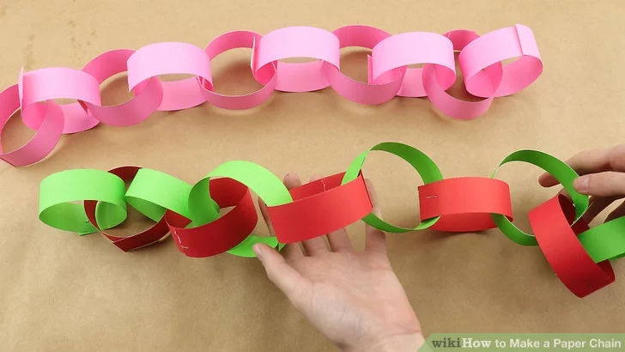
- Plan a family celebration-
  - Decide on a family celebration for the week. This could be a family indoor picnic, meal, dance etc. Ask your child to write invitations to family members to the party.
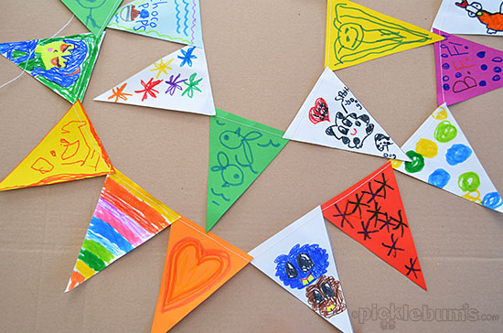
  - Create homemade decorations using coloured paper (If you do not have coloured paper at home, you could use old newspaper or wrapping paper) You could make paper chains or bunting
  - Plan a menu for the party and make the food together.

- Discover religious celebrations-
  - Watch the Let’s Celebrate video collection for Easter. Discuss the celebrations with your child. Did they celebrate Easter? Which of the events did they take part in?

  - Watch the Let’s Celebrate video collection for Eid-al-Fitr. Discuss the celebrations with your child. Did they celebrate Eid-al-Fitr? How did they celebrate? Are there any similarities and differences between the celebrations they saw in the Easter videos?

  - Look through the range of videos available on Cbeebies and watch together. Discuss who celebrates the event and any similarities and differences with celebrations your child has taken part in.
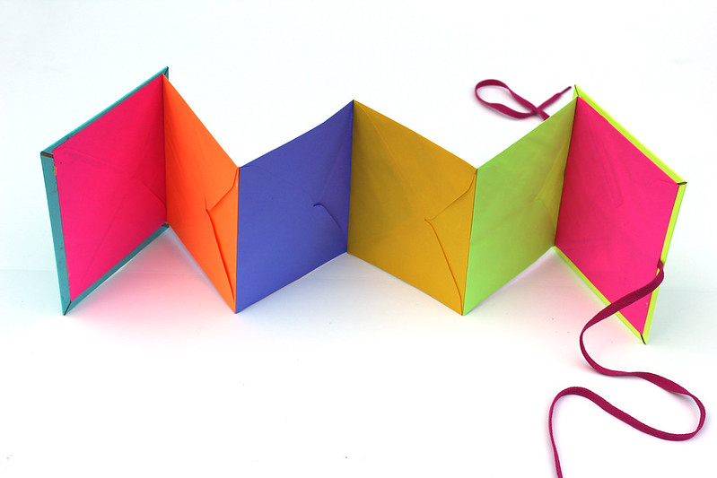
- Birthdays-
  - Talk to your child about when they were born. Look at photographs of the day they were born, if you have them available. Do they know the date of their birthday? Support your child to create an all about me folding book (as pictured) with their birth date, current age and anything else they think is important for people to know about them.
Additional learning resources parents may wish to engage with
Classroom Secrets Learning Packs - These packs are split into different year groups and include activities linked to reading, writing, maths and practical ideas you can do around the home.
Twinkl - to access these resources click on the link and sign up using your own email address and creating your own password. Use the offer code UKTWINKLHELPS.
Headteacherchat - This is a blog that has links to various learning platforms. Lots of these are free to access.
#TheLearningProjects

